**Unit testing documentation** 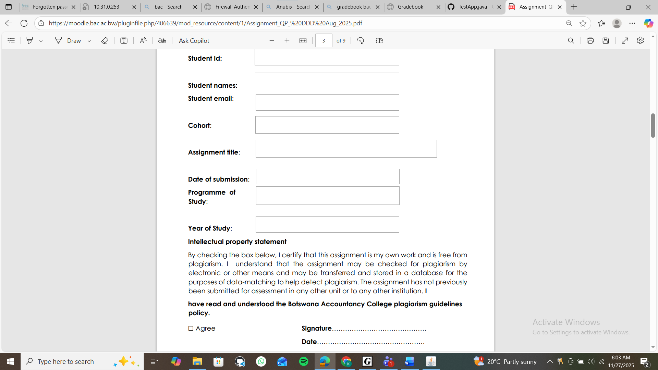



18 November 2025

Cse24-153@thuto.bac.ac.bw

18 November 2025

Year 2

Computer Systems Engineering

2024

Oriented Analysis and Design with Java

Theo Katso Mompati

Cse24-153

Lekgwere is a banking system that focuses on the conservation and value of wildlife. It highlights the vital role wildlife plays in the lives, culture, and economy of Batswana, emphasizing the need to protect and appreciate these natural resources for future generations.

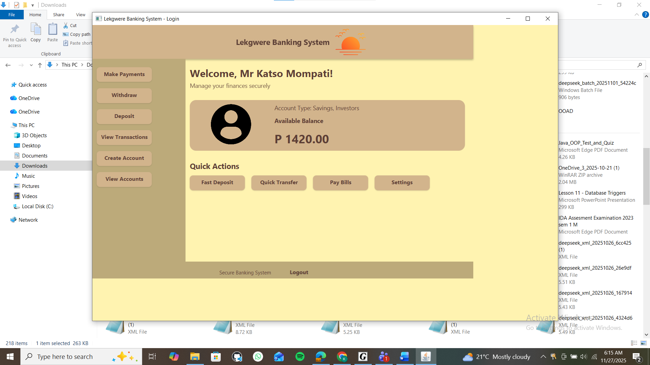

**Login screen**

The login screen provides a secure entry point for users to access the system. It displays fields where users can enter their username and password. Once the user submits their information, the system verifies the credentials against stored records. If the details are correct, the user is allowed to proceed to the main interface. If the credentials are incorrect, the screen alerts the user and requests them to try again. This ensures that only authorized users can access the system.

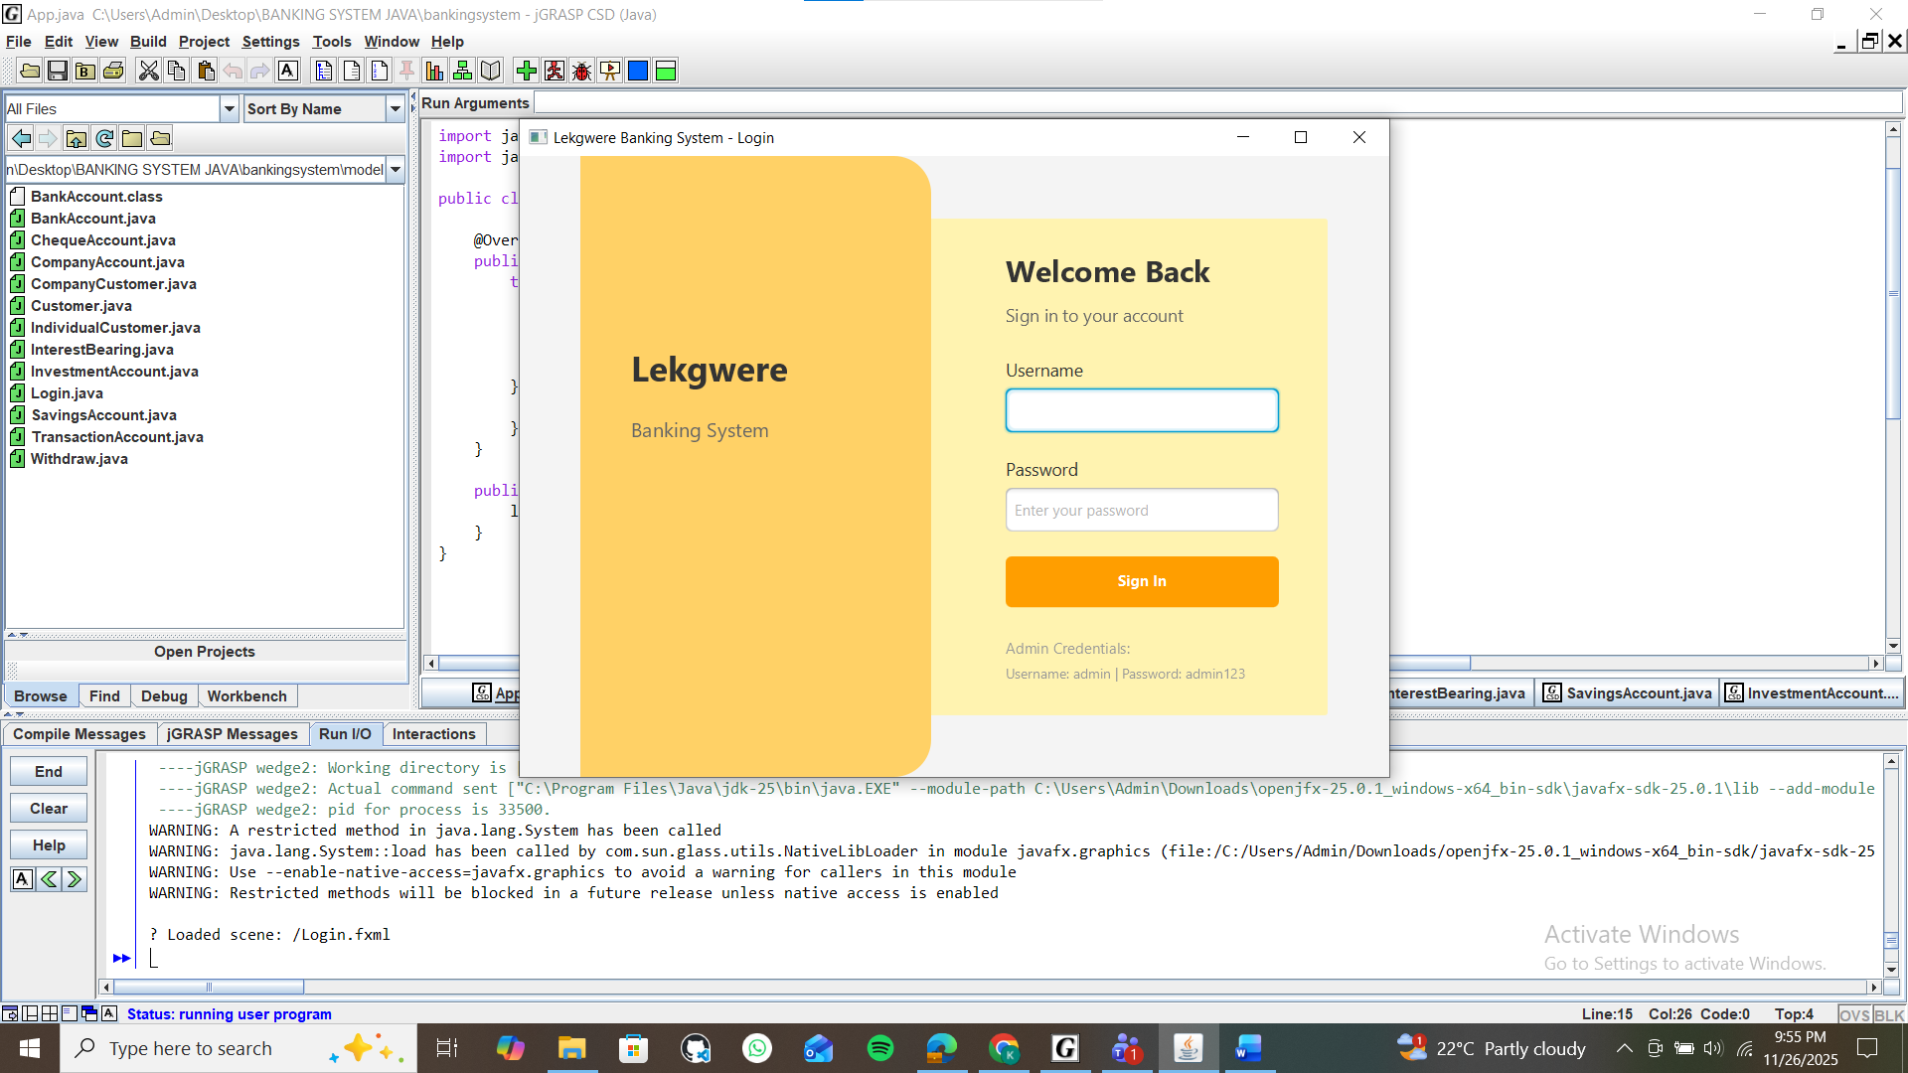

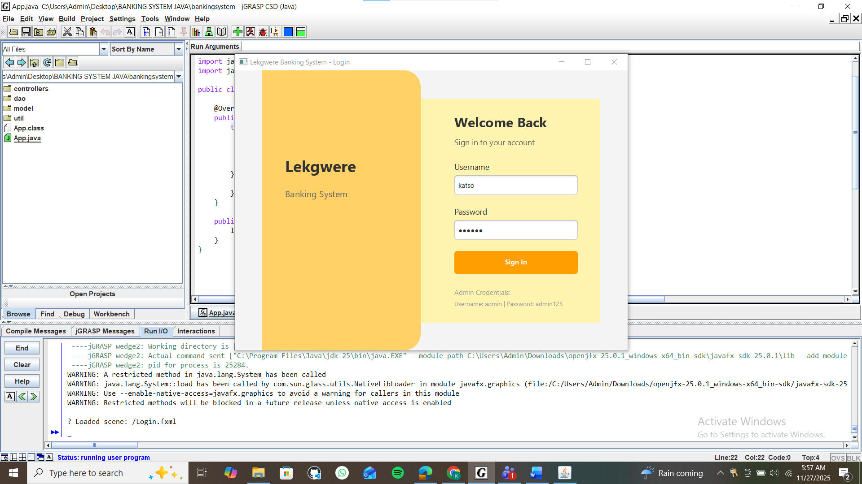

**Dashboard Screen**

The Lekgwere dashboard screen acts as the main hub of the wildlife-based banking system. After logging in, users are taken to this interface, where they can easily access all core features of Lekgwere. The dashboard provides clear navigation options for managing wildlife accounts, viewing conservation-related data, tracking transactions, and accessing educational resources about the importance of wildlife to Batswana. Its organized layout helps users move quickly between functions, making it simple to monitor activities and understand how wildlife contributes to the overall value stored within the system.

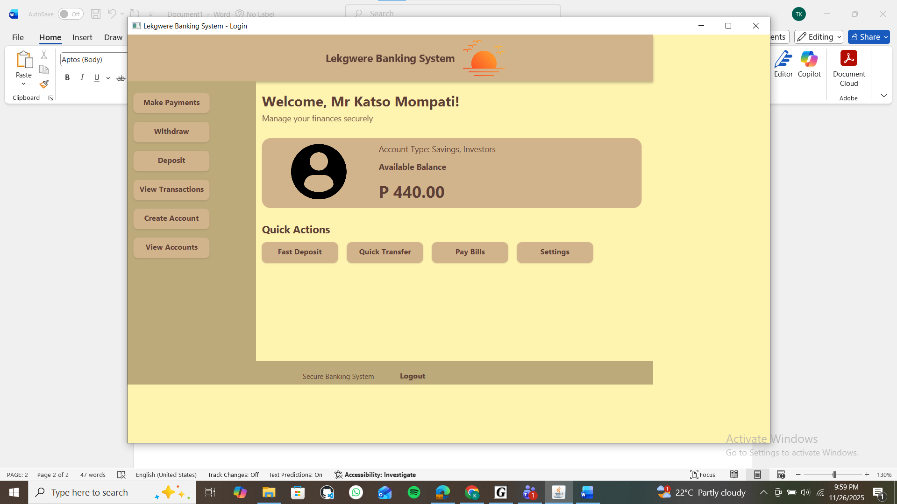

**View transactions**

The Transactions screen displays all financial or value exchanges linked to wildlife assets. Users can view deposits, withdrawals, transfers, and conservation-based incentives. The interface presents records in a clear format, making it easy to track activity and understand how wildlife contributes to the system’s financial flow. Filters and search options help users find specific transactions quickly.

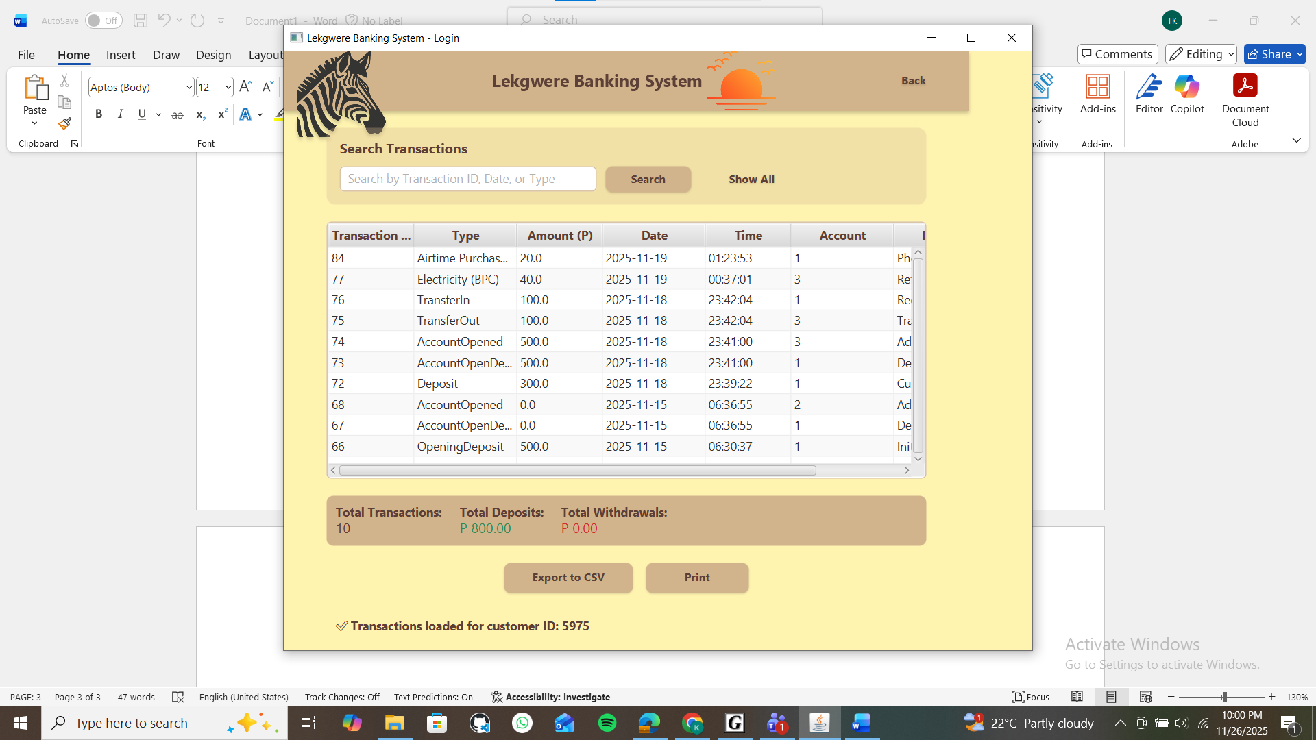

**CREATE NEW ACCOUNT**

Users may create as many accounts as they wish but with admin approval

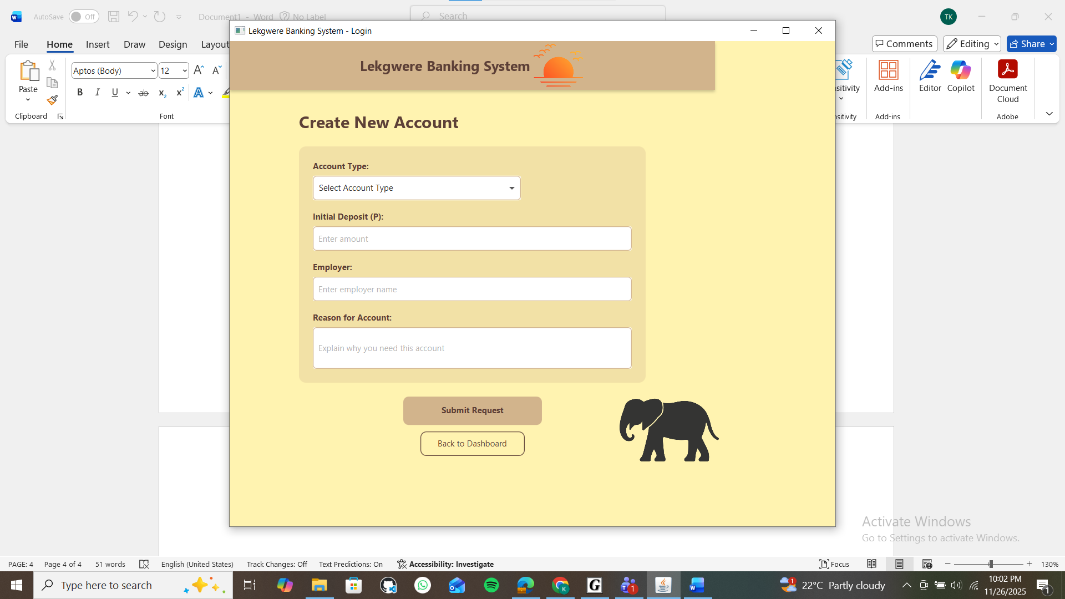

**Make payments screen**

The Make Payments screen allows users to transfer funds from their Lekgwere accounts to other accounts or pay for services within the system. Users select the source account, enter the recipient details and the payment amount, and then confirm the transaction. Once completed, the system updates both accounts and records the payment in the transaction history. This screen provides a secure and convenient way for users to manage payments while keeping accurate records of financial activities.A screenshot of a computer

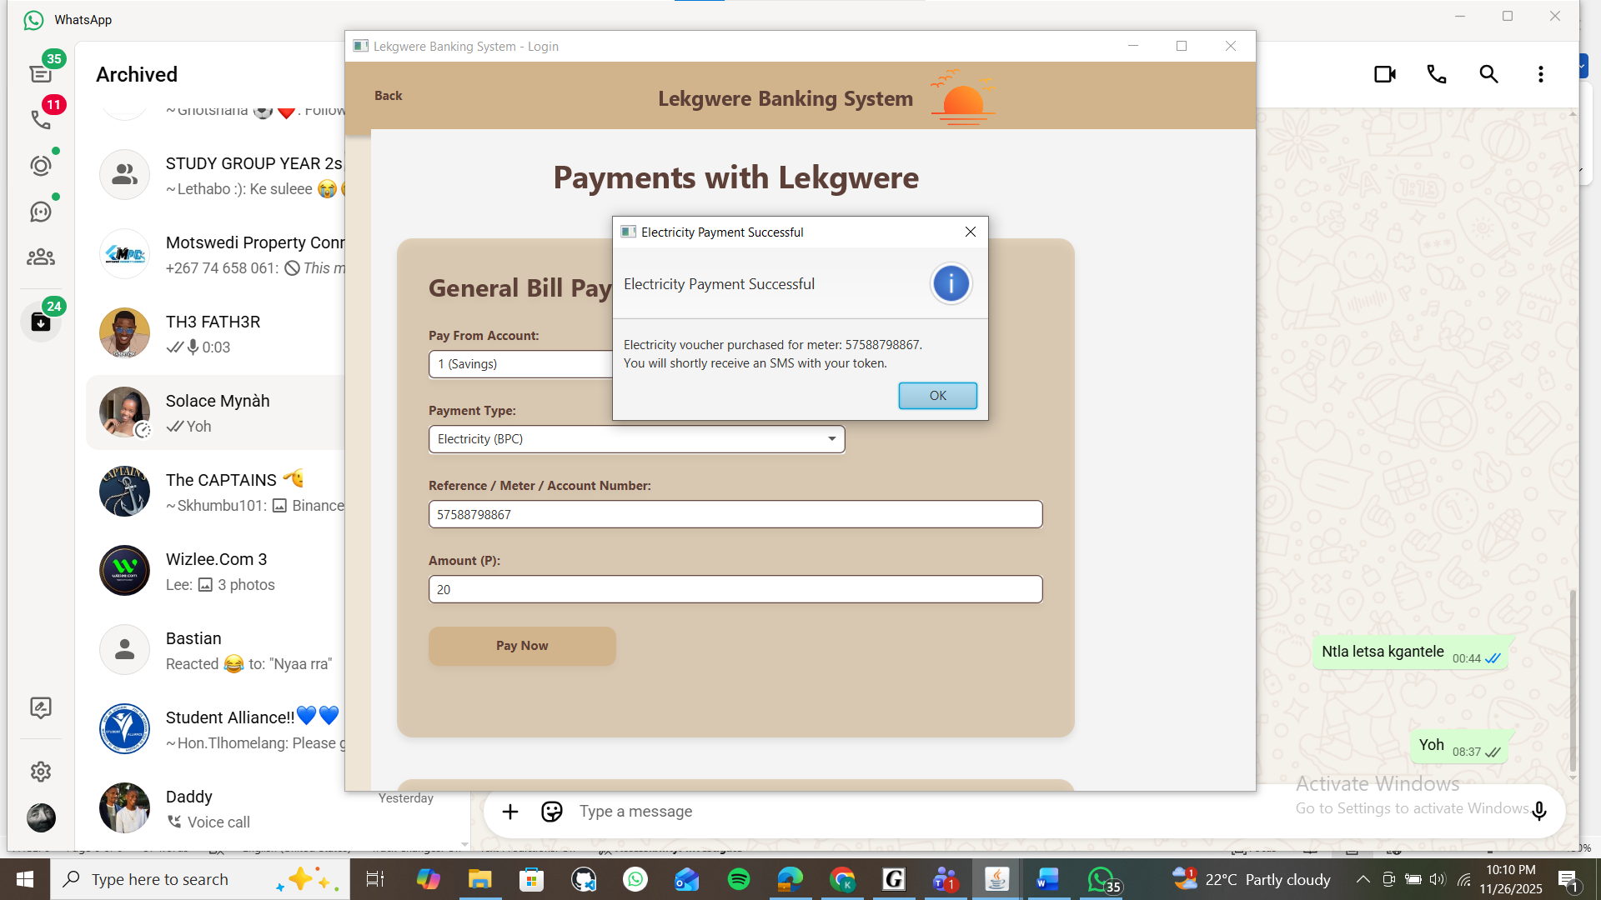

**TRANSCATION SCREEN**

**Transfer between accounts screen**

A user transfers funds between accounts

**Withdrawals screen**

The Withdrawals screen allows users to remove funds or value from their eligible Lekgwere accounts. All account types can perform withdrawals except for savings accounts, which are restricted to encourage long-term growth and conservation value. On this screen, the user selects an account, enters the withdrawal amount, and confirms the transaction. Once completed, the system updates the account balance and records the withdrawal in the transaction history for transparency

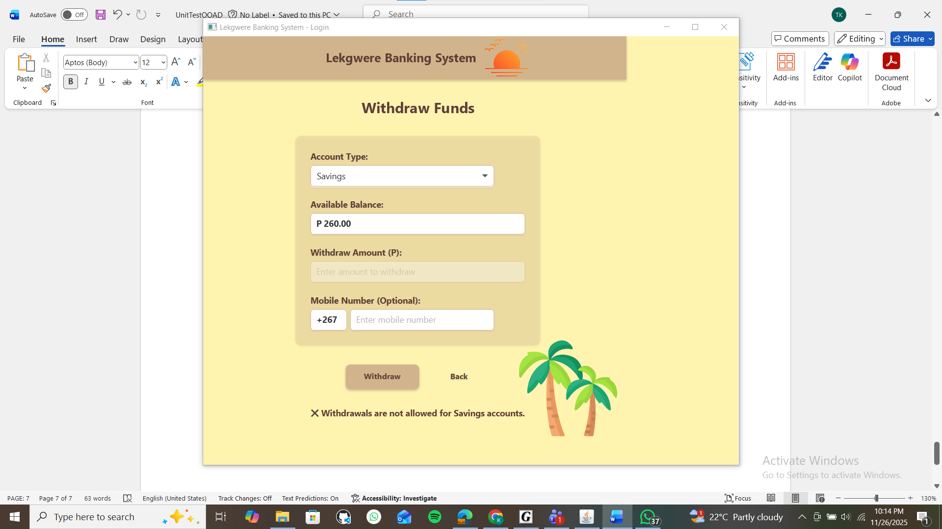

A customer is allowed to create as many accounts as they wish, but the admin maintains full control over all accounts. The admin reviews, approves, or manages these accounts to ensure proper use and system securityA screenshot of a computer

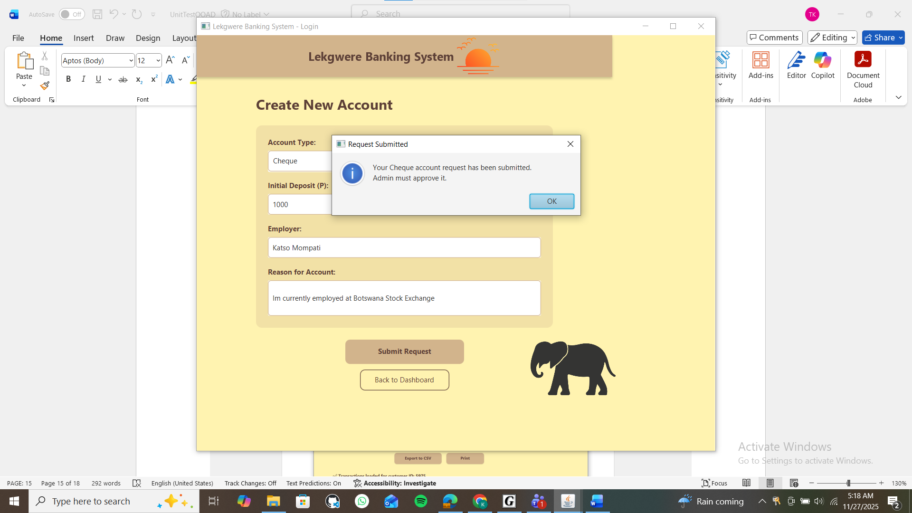

**Admin Approval Dashboard**

The admin has the authority to either approve or reject a customer’s account based on the reason provided during registration. If an account is rejected, the customer can follow up with the admin to request approval or provide additional information. This ensures that only valid and verified accounts are allowed into the system, while still giving customers an opportunity to resolve any issues.

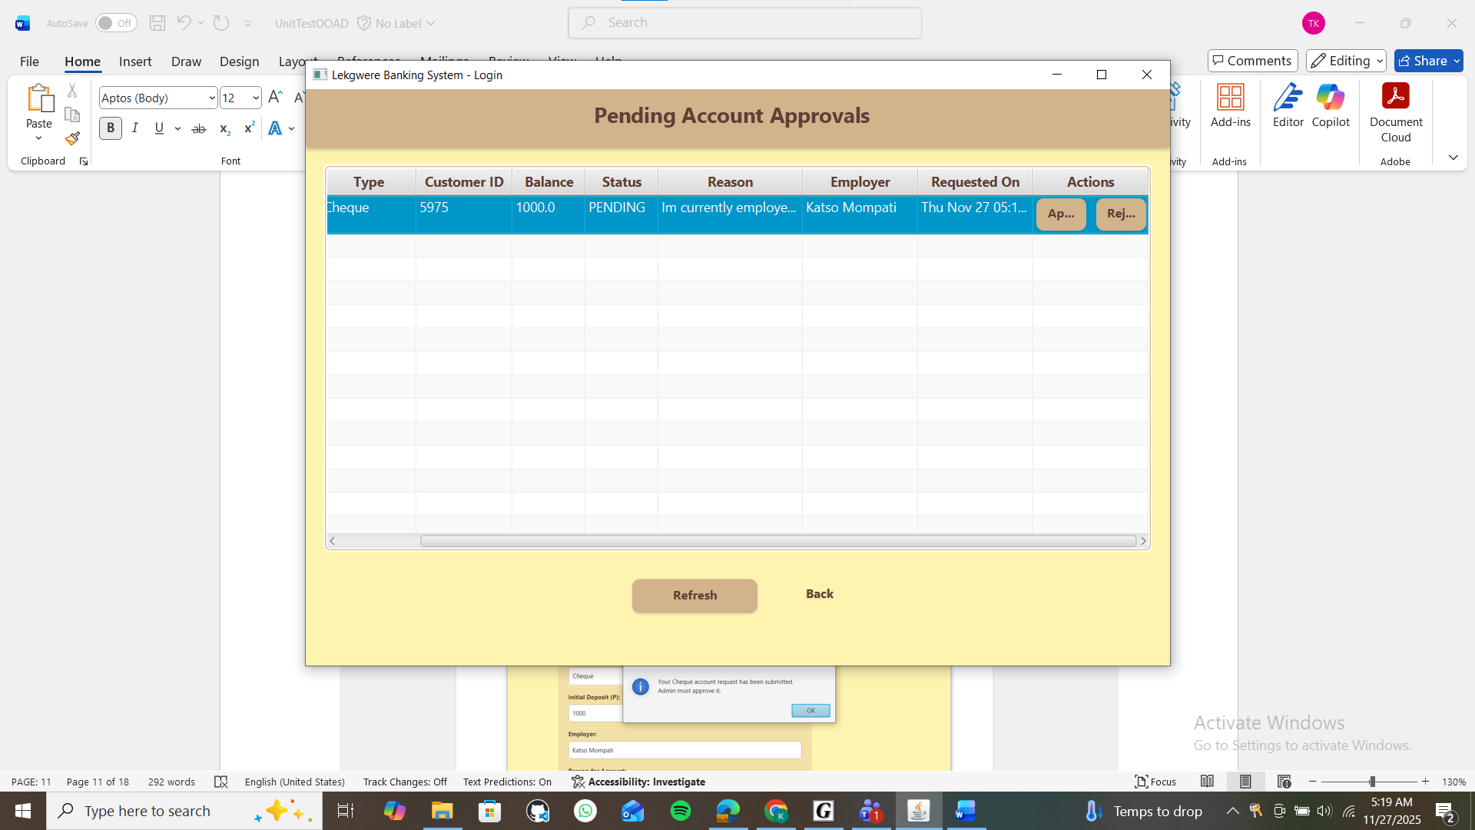

**Settings screen**

The Settings screen allows the user to manage and update their personal preferences within the Lekgwere system. From this screen, the user can change their password, delete their account if needed, and view all the accounts linked to their profile. The interface gives users full control over their security settings and account information, ensuring a safe and personalized experience.

**Deposit**

The deposit section allows the user to add funds or value into their Lekgwere account. The user selects the account they want to deposit into, enters the amount, and confirms the transaction. Once submitted, the system records the deposit and updates the account balance immediately. This feature helps users grow the value of their wildlife-linked accounts while keeping accurate and transparent transaction records. 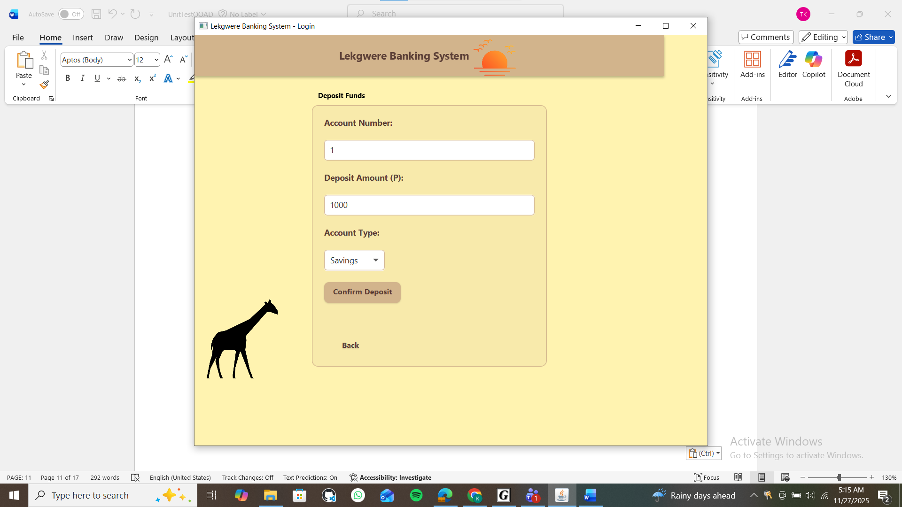

After a deposit is made, the updated amount appears in the dashboard under the account view. The transaction also shows up in the transactions list, confirming that the deposit was successful. A screenshot of a computer

That P1000.00 is added to the savings account.

Its appears into the transaction that a savings account which was opened with P1000.00

**Admin screen**

The Admin Screen serves as the central control panel for managing the entire Lekgwere system. From this interface, the admin can oversee customer accounts, review new account requests, approve or reject applications. The screen also provides access to customer lists and account lists. With full authority over all operations, the admin ensures that every account is valid, secure, and aligned with the system’s conservation principles.

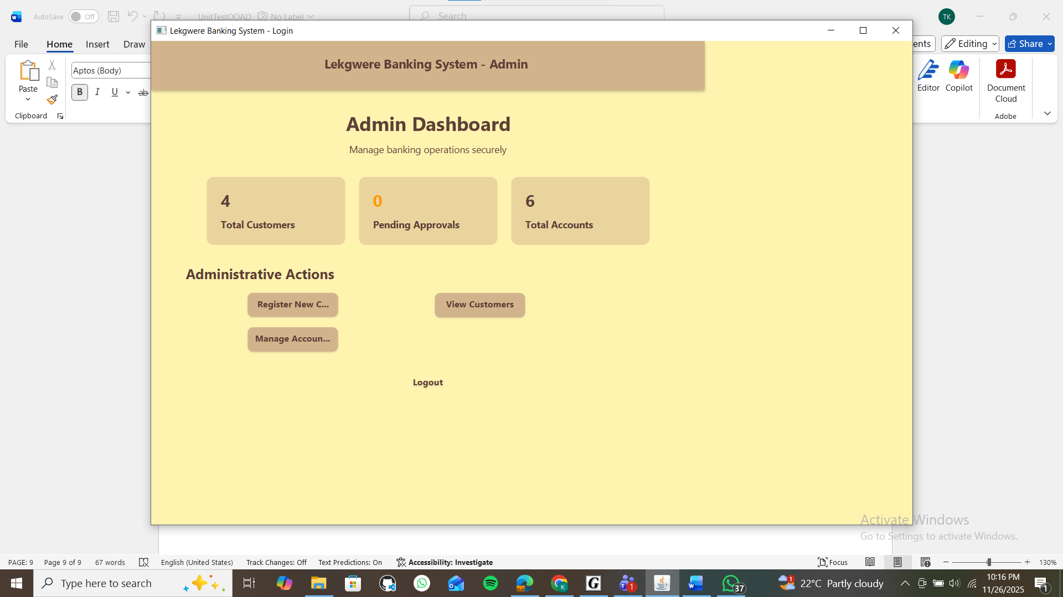

**Customer registration**

The Customer Registration screen is where new users are added to the Lekgwêrê system. Customers provide their personal details and create login credentials, which are then submitted for admin review. Once the information is captured, the system stores the registration request and waits for the admin to approve or reject it. This process ensures that every user entering the system is verified, secure, and properly documented before gaining full access.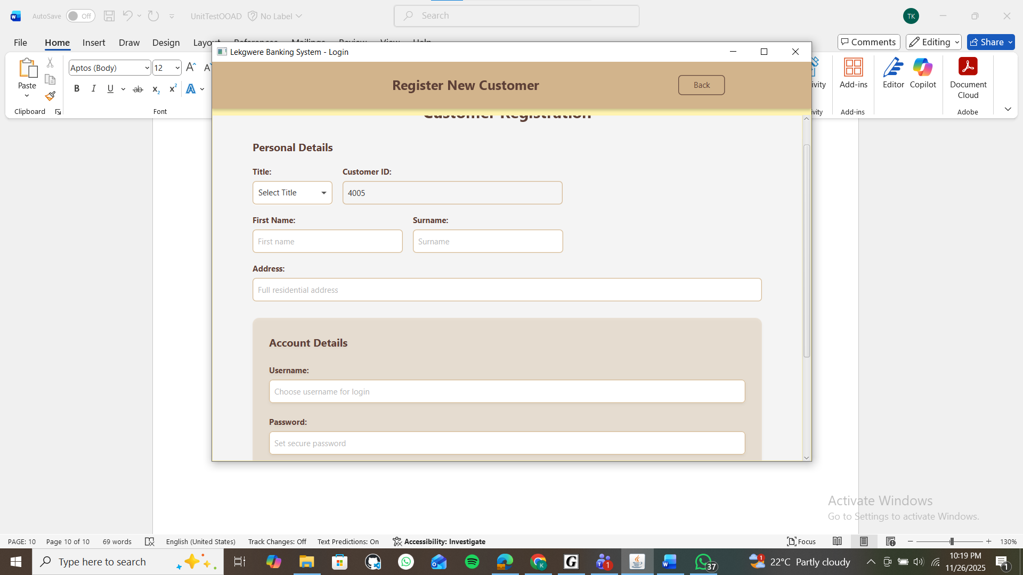

The system provides a detailed list of all customers along with their associated accounts. This list helps the admin quickly view customer information, check how many accounts each customer has created, and monitor the status of those accounts. Each entry displays key details such as account type, approval status, and recent activity. This organized view makes it easy for the admin to manage users, track account behavior, and ensure that the system runs smoothly and securely. A screenshot of a computer
